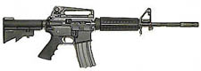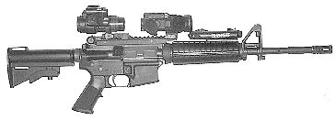
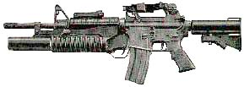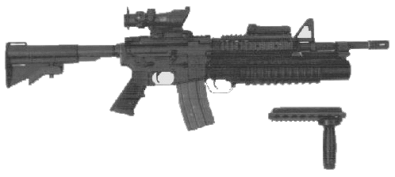
M4 Carbine
Ammo | Mag | Rng | ROF | Dam | Arm
5.56N | 20 / 30 | 30 / 35* | 4 | 2 | -
Description: The M4 (aka CAR-15) is a submachine gun version of the M16 originally designed for air crews and later adopted by Special Operations Units. The M4 can be set on semi, burst and full auto; it uses a common (5.56N) and potent round. The M4 can be fitted with an M203 Grenade Launcher. The maintenance is equal to that of the M16 – making it easier for troops to make the transfer from one weapon to the other and the *stock can be expanded for better accuracy. These are only SOME of the reasons why the M4 has been selected by most US Special Operations Teams as the weapon of choice.
Nation: United States Weight: 2.75 kg
Ammunition: 5.56N Magazine: 20 / 30
Price: $900 Availability: ( C/S )

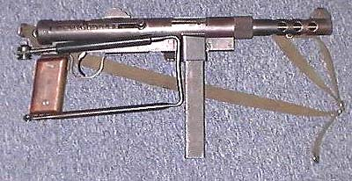
M-45 Swedish K
Ammo | Mag | Rng | ROF | Dam | Arm
9mm P | 15 / 30 | 30 | 3 | 1 | x2
Description: A Swedish built SMG that was widely sold throughout the world. It is highly favored by mercenaries and others desiring a weapon from a neutral, non-aggressive country (for political reasons).
Nation: Sweden Weight: 3.43 kg
Ammunition: 9mm P Magazine: 30
Price: $600 Availability: ( C/S )

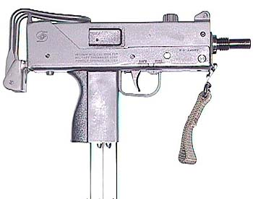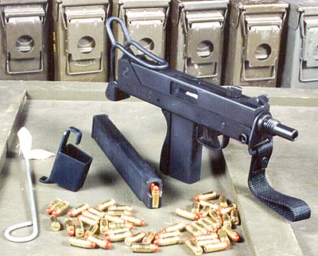
Ingram MAC 10/11
Ammo | Mag | Rng | ROF | Dam | Arm
.45 ACP  9mm P | 20  33 | 10  15 | 10  11 | 2  1 | x3  x2
Description: A very small submachine gun designed for clandestine operations and used (although never officially adopted) by various arms of the US military. The MAC-10 (also know as the M-10 or the Ingram) is available with a suppressor which reduces the sound of firing. Characters attempting to spot an MAC-10 fired using the suppressor get –25% to their RCN roll (M-11 is a –35%). The suppressor weighs .5 kg and costs $300.
Nation: United States Weight: 3.5 kg
Ammunition: .45 ACP / 9mm P Magazine: 20 / 33
Price: $500 / $475 Availability: ( C/S )

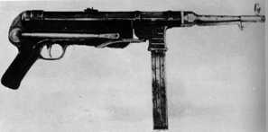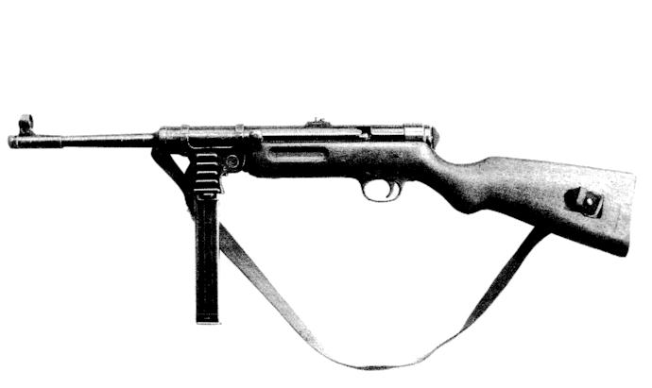
MP40 / MP41
Ammo | Mag | Rng | ROF | Dam | Arm
9mm P | 30 | 30 | 3 | 1 | x2
Description: Also called the Schmeisser, the MP-40 is one of the world’s most famous submachine guns. Developed for the Wehrmacht during WWII, the MP40 was the prototype for the majority of modern submachine gun designs and remained in service with many armies well into the 1970’s. By 2000 it was obsolete, but could still be found in the arsenals of many police forces and Third World armies. It is considered to be the first of the modern submachine guns.
Nation: Germany Weight: 4.03 kg
Ammunition: 9mm P Magazine: 30
Price: $1200 Availability: ( R/R )

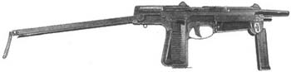
PM-63
Ammo | Mag | Rng | ROF | Dam | Arm
9mm M | 15 / 30 | 20 | 4 | 1 | x4
Description: A relatively small (33.3 cm) SMG, the PM-63 is often carried by Polish AFV crews and airborne forces. The weapon has a folding metal stock which can double as a handgrip and a progressive trigger. The PM-63 is often carried in a hip holster.
Nation: Poland Weight: 1.55 kg
Ammunition: 9mm M Magazine: 15 / 30
Price: $475 Availability: ( R/S )

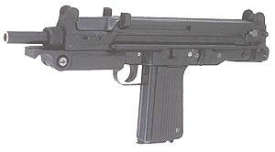
PM-84
Ammo | Mag | Rng | ROF | Dam | Arm
9mm P | 20 / 33 | 25 | 5 | 1 | x2
Description: Poland learned from the PM-63 what to do to make the 84 better. The 84 is slightly larger for better range, and uses the much more common 9mm Parabellum round. This allowed them to ability to make more for the open market, increasing revenues. The PM-84 has been well received by law enforcement, Polish troops, and civilians and government agencies from other countries use the PM-84.
Nation: Poland Weight: 2.05 kg
Ammunition: 9mm P Magazine: 20 / 33
Price: $850 Availability: ( R/S )

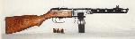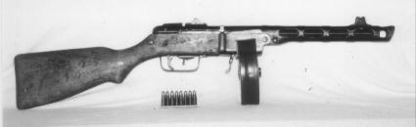
PPSh-41
Ammo | Mag | Rng | ROF | Dam | Arm
7.62mm T | 15 / 50 | 15 | 3 | 1 | x4
Description: A WWII vintage Soviet SMG, the PPSh-41 has also seen action in Korea and Vietnam It uses a high capacity drum that gives the weapon a very distinctive appearance, and caused it to be nicknamed “Stalin’s Banjo.” This weapon is no longer in Soviet service but can be found in many Third World arsenals.
Nation: USSR Weight: 3.5 kg
Ammunition: 7.62 T Magazine: 15 / 50
Price: $750 Availability: ( -/R )

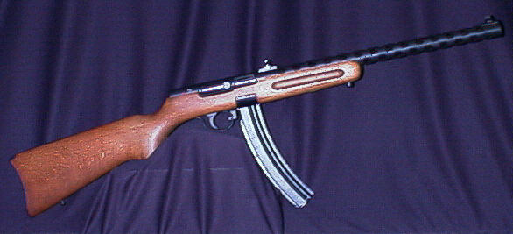
PPS-43
Ammo | Mag | Rng | ROF | Dam | Arm
7.62mm T | 15 / 30 | 15 | 4 | 1 | x4
Description: Another WWII vintage Soviet SMG, the PPS-43 has a folding stock and can use the same box magazine as the PPSh-41 (not the drum). This weapon is no longer in Soviet service, but can still be found in many Third World arsenals and among civilians who have had them passed down (and hidden) to them from relatives that used them in the war.
Nation: USSR Weight: 3.36 kg
Ammunition: 7.62mm T Magazine: 15 / 30
Price: $800 Availability: ( -/S )
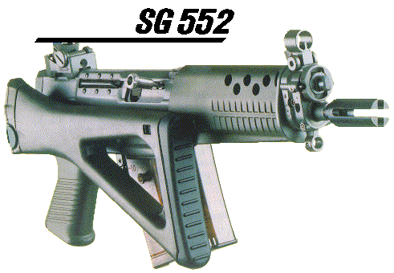
SIG SG 552 Commando
Ammo | Mag | Rng | ROF | Dam | Arm
5.56 N | 20 | 30 | 4 | 2 | -
Description: Many law enforcement agencies have adopted the SG 552 as the standard weapon for SWAT teams and Drug Task Forces. The features that come on the 552 have made it a highly desired weapon for gadget thrill seekers. A Mag-Lite © built into the weapon (above the barrel), the laser sight built in below the barrel, composite folding stock and magazines that can be easily AND STURDILY attached to one another, are only a few options that the Commando has for its users. The SIG has been compared by some to the M4, though purists claim there is no comparison – unlike the M4, one cannot attach an M203 to the Commando. For loyal SIG owners and gadget fanatics, nothing else will do. Excellent weapon.
Nation: United States Weight: 3 kg
Ammunition: 5.56 N Magazine: 20
Price: $950 Availability: ( S/R )
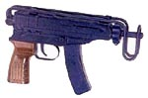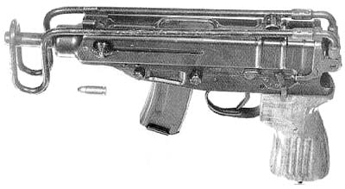
Skorpion
Ammo | Mag | Rng | ROF | Dam | Arm
.32 ACP | 7 / 15 / 25 | 10 | 8 | 0 | x4
Description: Commonly referred to as a machine pistol, the Skorpion is small enough to be carried in a shoulder holster. Its short range and under-powered ammunition make it of limited combat value, but its ease of concealment and high rate of fire have make it very popular with Warsaw Pact covert agents.
Nation: Czechoslovakia Weight: 1.50 kg
Ammunition: .32 ACP Magazine: 7 / 15 / 25
Price: $480 Availability: ( R/S )

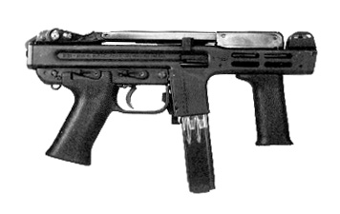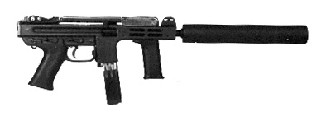
Spectre
Ammo | Mag | Rng | ROF | Dam | Arm
9mm P | 15 / 30 | 20 | 6 | 1 | x2
Description: The Spectre is a common submachine gun with British forces. High rate of fire, decent accuracy, and good reliability have given the weapon a place in covert operations. It is relatively small but the front hand grip helps keep the weapon stable during firing.
Nation: United Kingdom Weight: 2.75
Ammunition: 9mm P Magazine: 15 / 30
Price: $845 Availability: ( S/- )
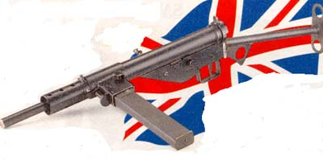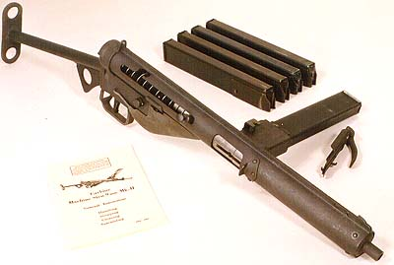
Sten Mk II
Ammo | Mag | Rng | ROF | Dam | Arm
9mm P | 20 / 30 | 30 | 4 | 1 | x4
Description: A WWII vintage British submachine gun from metal stampings for ease of production. It was the standard SMG for British and Canadian forces. The British manufactured and distributed thousands of Sten guns to underground forces opposing the Axis during WWII, and the weapon was in service with some Third World armies well into the 1990s. It’s a reliable (easy to maintain and fix) weapon. It’s not as fast as others but it has a good range.
Nation: United Kingdom Weight: 2.8 kg
Ammunition: 9mm P Magazine: 20 / 30
Price: $400 Availability: ( C/S )

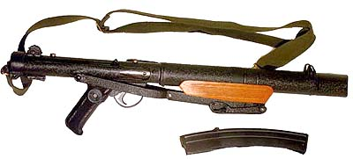
Sterling
Ammo | Mag | Rng | ROF | Dam | Arm
9mm P | 20 / 30 | 25 | 5 | 1 | x2
Description: The standard military submachine gun of the British Army, the Sterling has also found its way into general use.
Nation: United Kingdom Weight: 3 kg
Ammunition: 9mm P Magazine: 20 / 30
Price: $700 Availability: ( C/S )

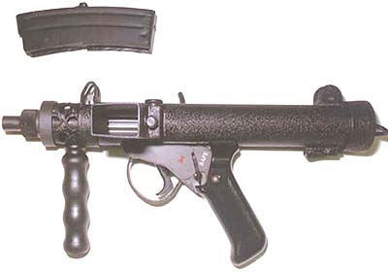
Sterling Paratrooper Pistol
Ammo | Mag | Rng | ROF | Dam | Arm
9mm P | 17 | 15 | 8 | 1 | x2
Description: A miniature version of the Sterling submachine gun, the Sterling pistol was designed for use by British paratroopers. The SPP is compact and quick. It’s simple moving parts make it easy to work with in maintaining, repairing, and even modifying. The magazines are interchangeable with the Sterling SMG
Nation: United Kingdom Weight: 1.6 kg
Ammunition: 9mm P Magazine: 17
Price: $800 Availability: ( S/R )

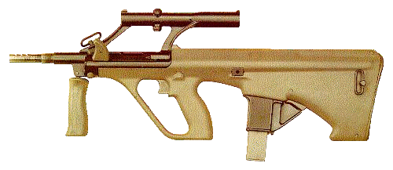
Steyr AUG 9mm
Ammo | Mag | Rng | ROF | Dam | Arm
9mm P | 20 / 30 | 30 | 5 | 1 | x2
Description: A quasi-assault rifle, the AUG 9mm, is still considered a submachine gun because of the caliber (9mm P) and its size. The Steyr is very accurate and reliable in harsh condition. Referees should take this into consideration when characters have to maintain weapons.
Nation: Austria, Australia Weight: 3.2 kg
Ammunition: 9mm P Magazine: 20 /30
Price: $850 Availability: ( S/R )

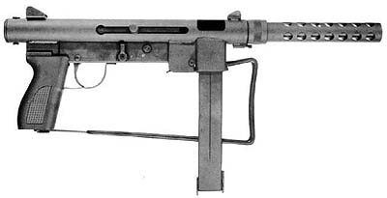
S&W Model 76
Ammo | Mag | Rng | ROF | Dam | Arm
9mm P | 20 / 30 | 30 | 4 | 1 | x2
Description: The S&W M76 follows the conventional SMG pattern, and at one time was considered for use by the U.S. military. The M76 was first manufactured in the middle and late 1960’s, with production ceasing for a time with police and security agencies.
Nation: United States Weight: 3.28 kg
Ammunition: 9mm P Magazine: 20 / 30
Price: $800 Availability: ( S/- )

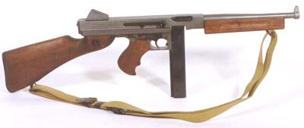
Thompson M1A1
Ammo | Mag | Rng | ROF | Dam | Arm
.45 ACP | 10 / 20 / 50 drum | 18 | 4 | 2 | x3
Description: the last version of the venerable “Tommygun.” Too late for action in WWI, it was used by American gangsters in the late 1920’s and 30’s. It was obsolete by WWII but was still used. Later variants could use only a 10 or 20 shot box magazine. Referees should double the price for versions that also accept the 50 round drum. The Drums themselves are nearly impossible to find as well.
Nation: United States Weight: 4.9 kg
Ammunition: .45 ACP Magazine: 10 / 20 or 50
Price: $1000 Availability: ( S/- )

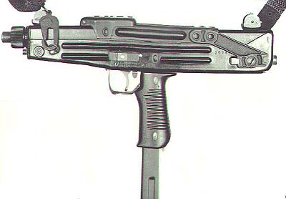
Z84
Ammo | Mag | Rng | ROF | Dam | Arm
9mm P | 15 / 30 | 20 | 5 | 1 | x2
Description: Spanish submachine gun used by Security Forces and some military applications. Security and police mainly use the weapon. It gets its boxy design from the Uzi, which it slightly resembles internally as well as externally. It is smaller than the Uzi and is usually carried under the arm on a sling for concealability and ease of use.
Nation: Spain Weight: 2.75 kg
Ammunition: 9mm P Magazine: 15 / 30
Price: $650 Availability: ( S/- )

